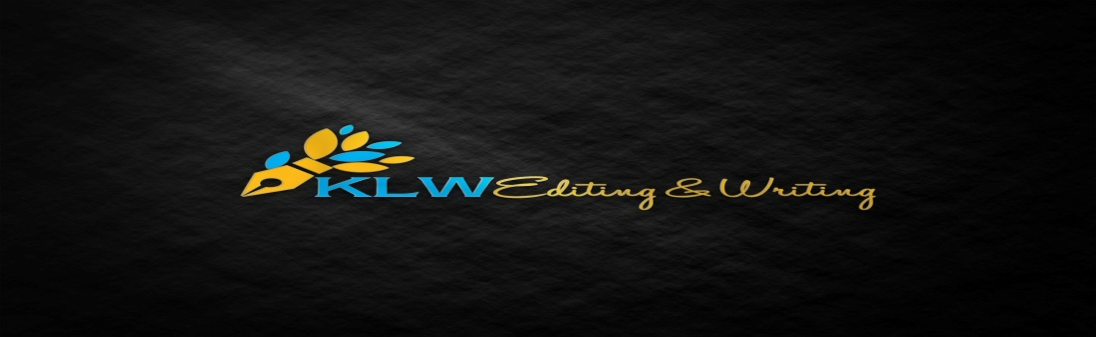
KLW Editing & Writing Services, LLC

- What is your primary industry or profession you want to highlight on your resume? If you’re looking to change, please detail what new industry you want to apply for.

Office
240 Herndon Ave.
New Castle, VA 24127

Phone
540-598-3972

Email
kristywyatt@gmail.com

Web
www.klwwriting.com

- What specific types of jobs are you looking for? (If possible, please provide 2-3 links to jobs you are interested in, or a thorough description of the type of job you’re looking for and the job’s primary responsibilities.)
- For each job/position you’ve had (focus on the past 10 years), have you had any major accomplishments associated with them? (Be as detailed as possible.)
- Would you want any help with doing online job applications?
- Do you already have an old and/or out-of-date copy of a resume/cover letter? If so, please attach (if able) when sending back this questionnaire.
- Do you have any supporting documents? I.e., reference letters, awards, research statements, certifications, etc.
- Please use the space below to add any specific details you want in your resume or other career documents.

